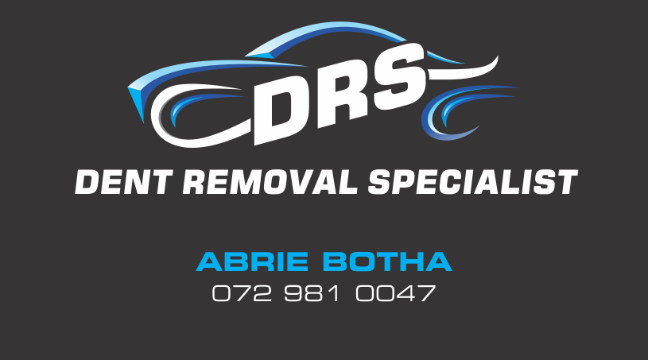

# ABOUT US

DRS Dent Removal Specialist is a company that offers Mobile Paintless Dent Removal, Hail Damage, Buff and Polish, Head Light Restoration, Mag and Rim Repairs, Minor scratch removal with reasonable prices, good quality and exceptional service.

We have qualified technicians operating mobile units and a workshop servicing the Western Cape.

We strive to have you as one of our clients and look forward to doing business with you.

**PAINTLESS DENT REMOVAL**

**Pressing Technique:**

Paintless dent removal is the art of using specially designed tools to remove dents without panel beating or spray painting. O ur qualified dent technicians have been trained to use these specialised tools to access the dents, whether on your doors, bonnet, roof, fenders or boot and massage the dent from the inside out until the damaged area is undetectable.

**Gluing Technique:**

At points that are inaccessible from the inside, a special adhesive is used to place small studs on the dent; these are then removed using a tension hammer without damaging the paint.

**Benefits of Paintless Dent Removal:**

* The original paint remains
* No value reductions when reselling the vehicle
* Repair method is recommended by manufacturers and insurance companies
* Fast and reliable repairs
* Environmentally friendly
* Mobile service is on location within 48 hours

What should you look for to determine whether the dent can be removed using the paintless dent removal system?

* Paintwork should not be damaged
* Dent should not be on a body line
* Dent should not be on the edge of any panel

HOW TO REDEEM THE VOUCHER

* Purchase the DRS voucher from your Service Advisor
* Voucher is suitable for a panel of dents and dent may not be larger than a radius of 15 cm
* Contact DRS with voucher number (top right corner at back of voucher) to redeem and schedule suitable time
* The service can be provided from our workshop or a mobile unit can assist but not at the dealership where the voucher was purchased

MOBILE VS WORKSHOP

|  |  |
| --- | --- |
| Please note that not all work can be done mobile and to ensure the best quality and workmanship it has to be allocated to the workshop that is situated in Brackenfell, just off the N1 on Okavango. | C:\Users\Abrie Botha\Downloads\DRS Flyer A6_BACK (2).jpg |